1. **What is software? What is software engineering?**

Software:-

* Software is that we cannot be physically touched.
* It is the collection of data, a program that can used to run the machine.
* Examples like MS Office, Powerpoint, etc....

Software engineering:-

* Software engineering creates applications, video games, operating system using the coding as per the customer requirements.

1. **Explain types of software.**

There are 5 types of software:-

1. Application Software
2. System Software
3. Driver Software
4. Middleware
5. Programming Software
6. Application Software:-

* It is a computer program to design perform the specific task to the user.
* The software which is come already installed with computer.
* Examples MS office, PowerPoint etc.….

1. System Software:-

* It is computer program that is designed to run a computer’s hardware and applications programs.
* It provides the platform for the other software.
* Examples Windows, Linux etc.....

1. Driver Software

* It is allowing your operating system to start, use and control a hardware device.
* Driver is the translator that your operating system to ask hardware devices to your computer that is what do you want.

1. Middleware

* It is used for communication between two different types of software.
* For example, middleware enables Microsoft windows to talk to Excel and Word.

1. Programming Software

* Software programming is the act of writing computer code.
* Programming software can allow the user to create an application and provides the tools to develop, write, test, debug .

1. **What is SDLC? Explain each phase of SDLC.**

* The software development life cycle (SDLC) is the process that creates software using the basis of instructions, and analysis.
* Phases of SDLC:-

1. Requirement Gathering
2. Analysis
3. Designing
4. Coding or Implementation
5. Testing
6. Maintenance
7. Requirement Gathering:-

* It is important to understand the client’s requirements that what type of the software they want and based on that information we can plan to create software.

1. Analysis:-

* After collecting the requirements of the client, we can analyze the strengths and weaknesses of our system and the difficulties are occur in creating the software.

1. Designing

* After the analysis we create the design of the software, how it looks and its visual appearance.

1. Coding or Implementation

* After these stages we do the coding using the programming language.

1. Testing

* After the implementation of coding, we need to do the testing of the software that everything is working perfect as per the client requirements.

1. Maintenance

* Final stage is the maintenance of the software. Day-to-day update is also important for the software.

1. **What is DFD? Create a DFD diagram on Flipkart.**

* DFD means Data Flow Diagram. It is a representation of the flow of data through a system.
* DFD is a graphical tool, useful for communicating with users ,managers.
* DFD can be represented in many ways.
* DFD belongs to structure analysis tools. It is very popular because they can help us visualize the major step.

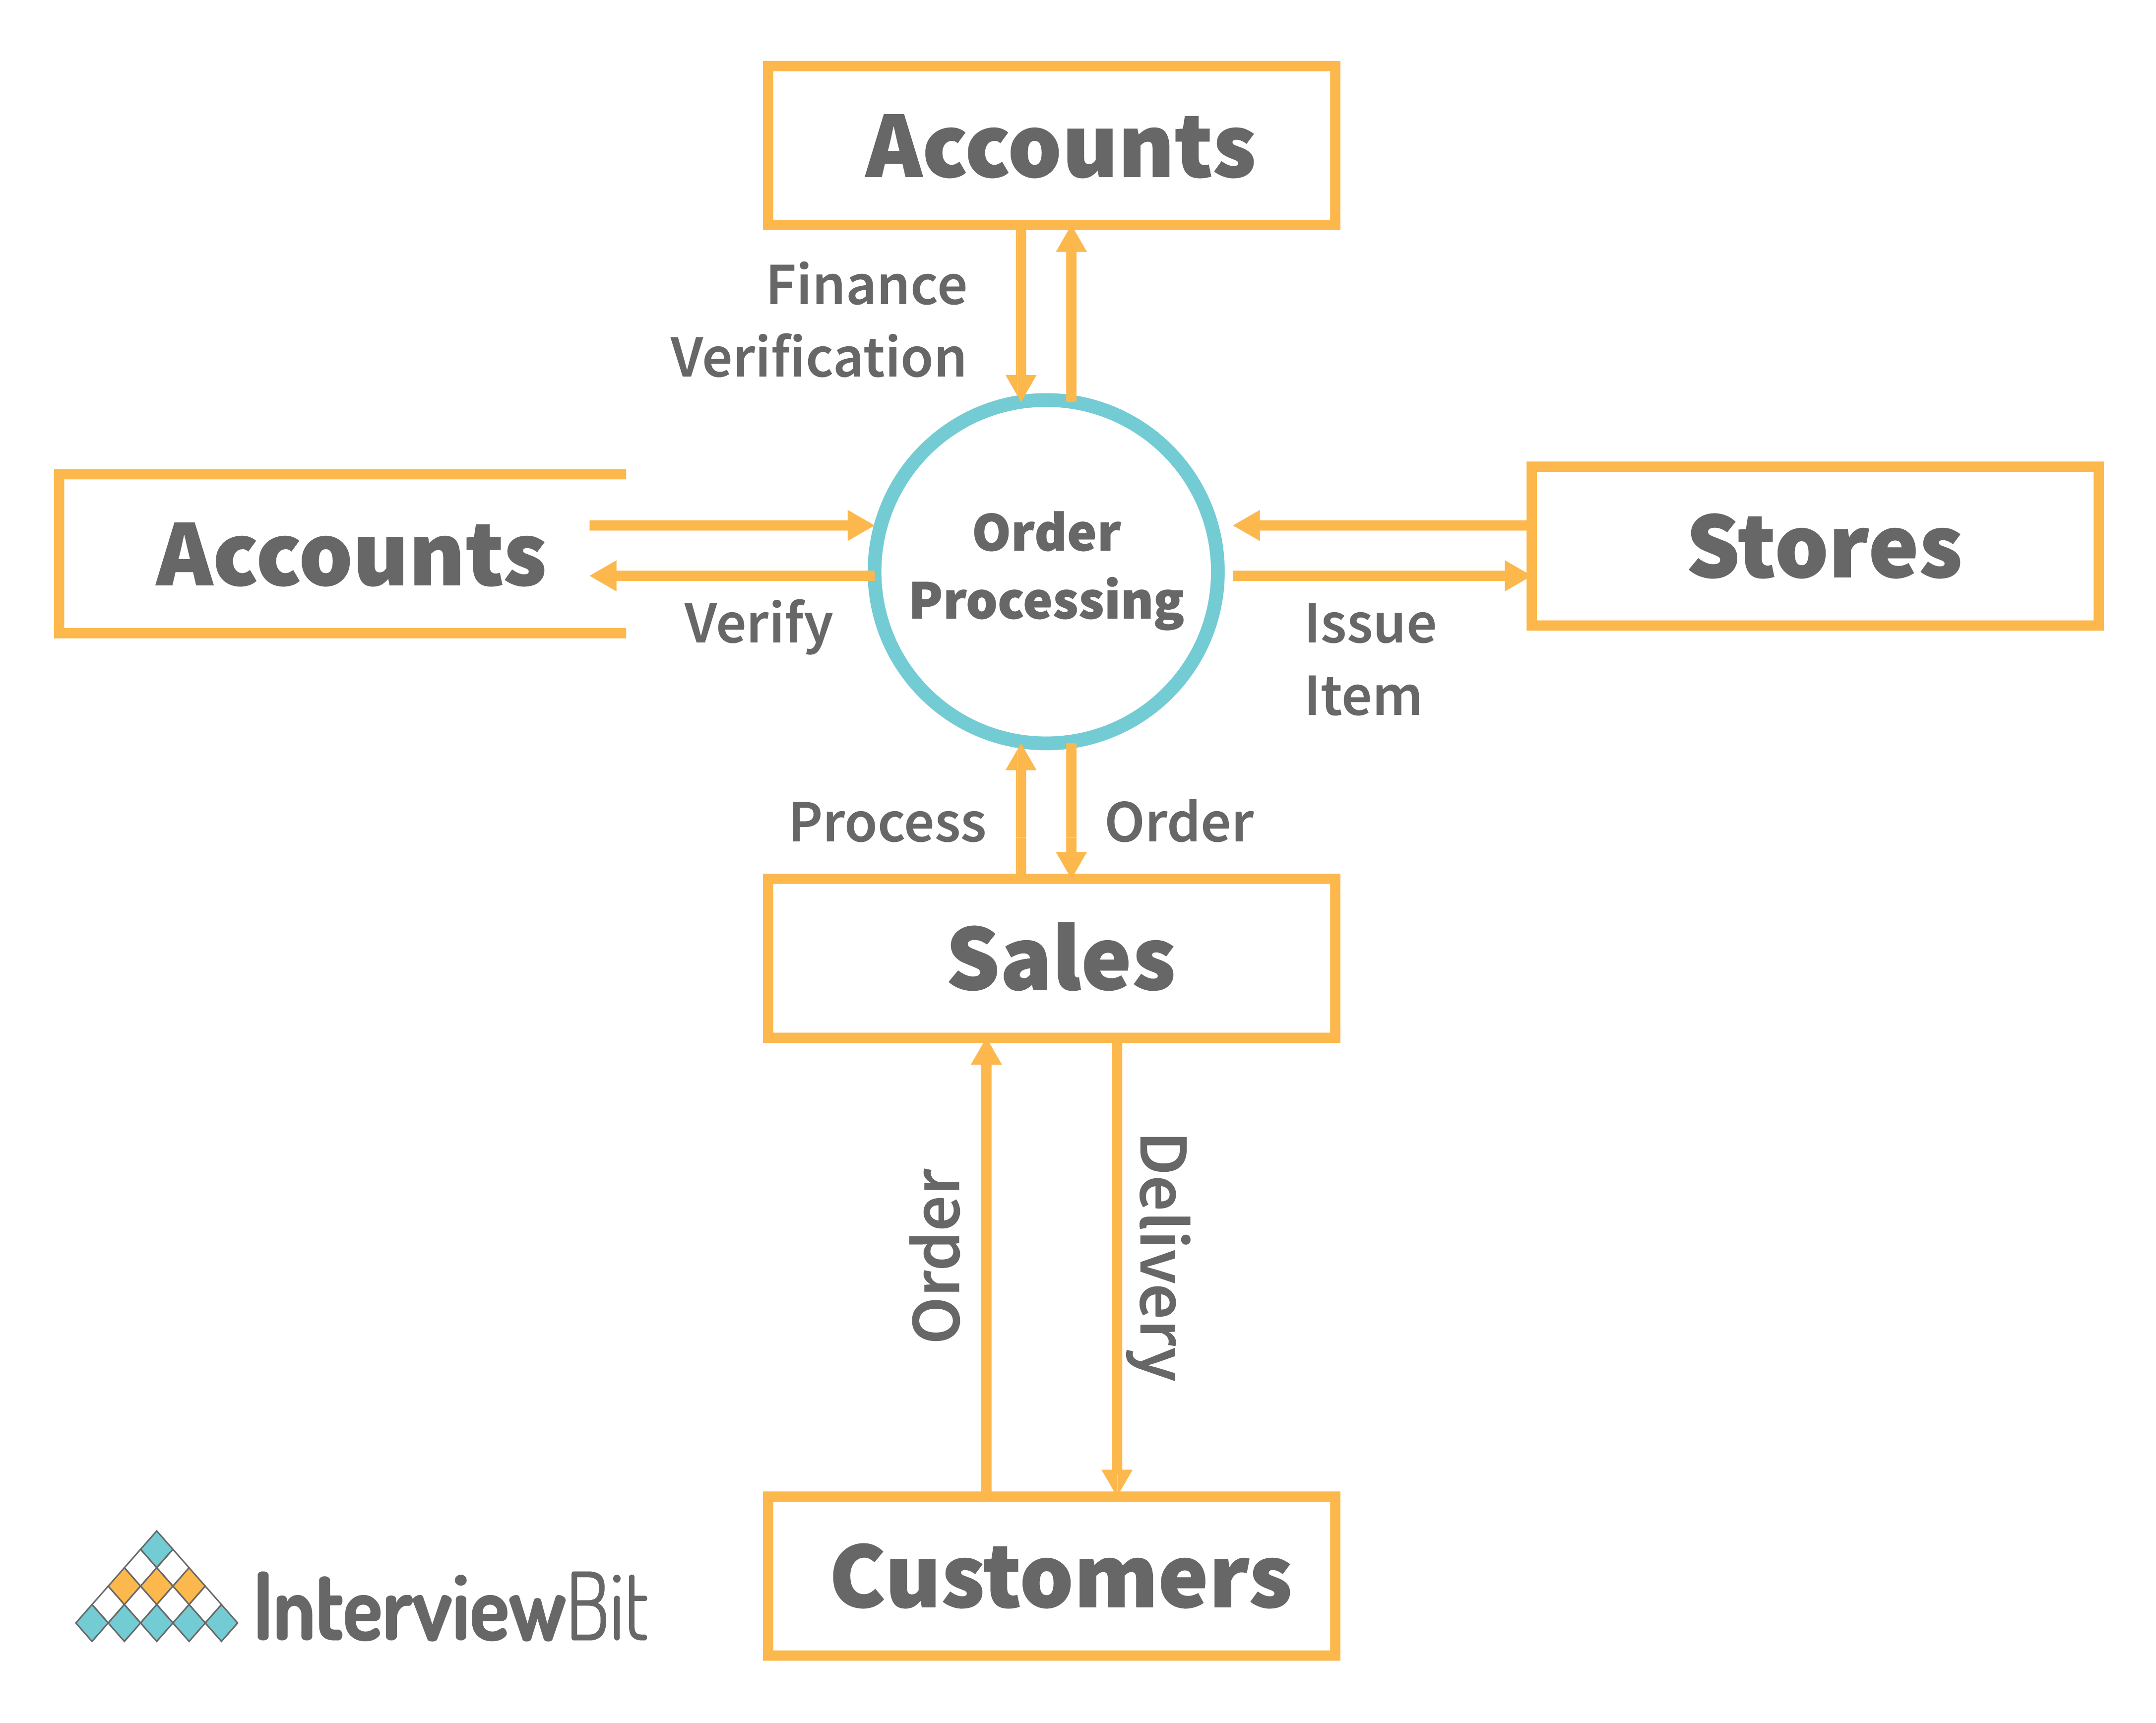

1. **What is Flow Chart? Create a flowchart to make addition of two numbers.**

* A flow chart provides a visual of how a product should work, how a project should flow, or how a network can function before it’s built.
* Flow charts are used to design simple processes or programs.
* It represents an illustration of a solution model to a given problem.
* It is used to analyze, design, managing a process in various fields.

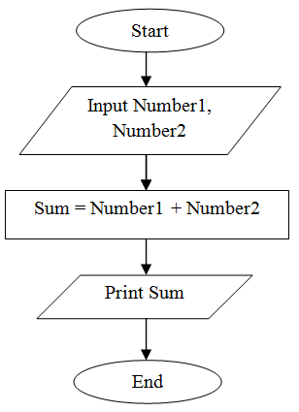

1. **What is a Use case Diagram? Create a use-case on bill payment on Paytm.**

* We can describe a use case is how a user interacts with a system or product.
* Companies build use cases to establish success and failure scenarios.
* Use case can help to provide a higher-level view of the system.
* Use case diagrams are the blueprints for your system.
* It is a mimic of the real product and provides the view for the others to understand how the system is designed.

